Duolingo Meme Marketing Case Study & Its Application to TRESemmé
Business Case Competition | Marketing Strategy Analysis

PART 1: Duolingo Case Study Summary
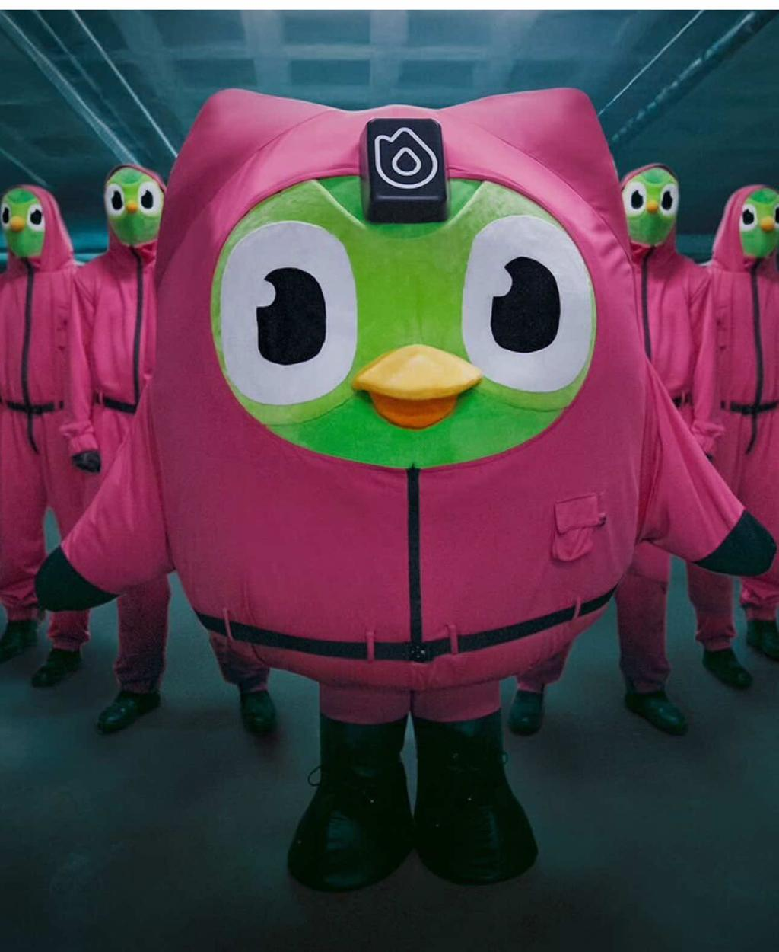

Duolingo: Turning Internet Culture into Brand Entertainment
Source: TikTok for Business, TikTok Ad Awards 2025

1. Campaign Overview
Duolingo's Cult Mass campaign demonstrates how a brand can transform an internet meme into a larger storytelling experience. Rather than relying on conventional advertising, Duolingo used its iconic owl mascot, Duo, to create a humorous, serialized narrative that encouraged audiences to participate in its online culture.
The campaign followed a viral moment in which Duo was declared dead. Instead of allowing the trend to disappear, Duolingo revived the character and reimagined him as a cult leader, building an entire fictional universe around the event.
The campaign was designed primarily for TikTok, where users could engage with the story, share content, and participate in the growing conversation.
TikTok For Business

2. Campaign Objectives
The campaign had three main objectives:
- Cultural relevance: Establish Duolingo as a brand that actively participates in internet culture rather than simply advertising to its audience.
- Community engagement: Encourage users to interact with and contribute to the brand's ongoing narrative.
- Brand awareness: Generate widespread attention through TikTok-native entertainment and distinctive creative content.
Duolingo's mascot, Duo, was central to this strategy. By maintaining a recognizable personality across its content, the company turned the mascot into an ongoing source of entertainment and conversation.
TikTok For Business

3. Campaign Execution and Technical Strategy
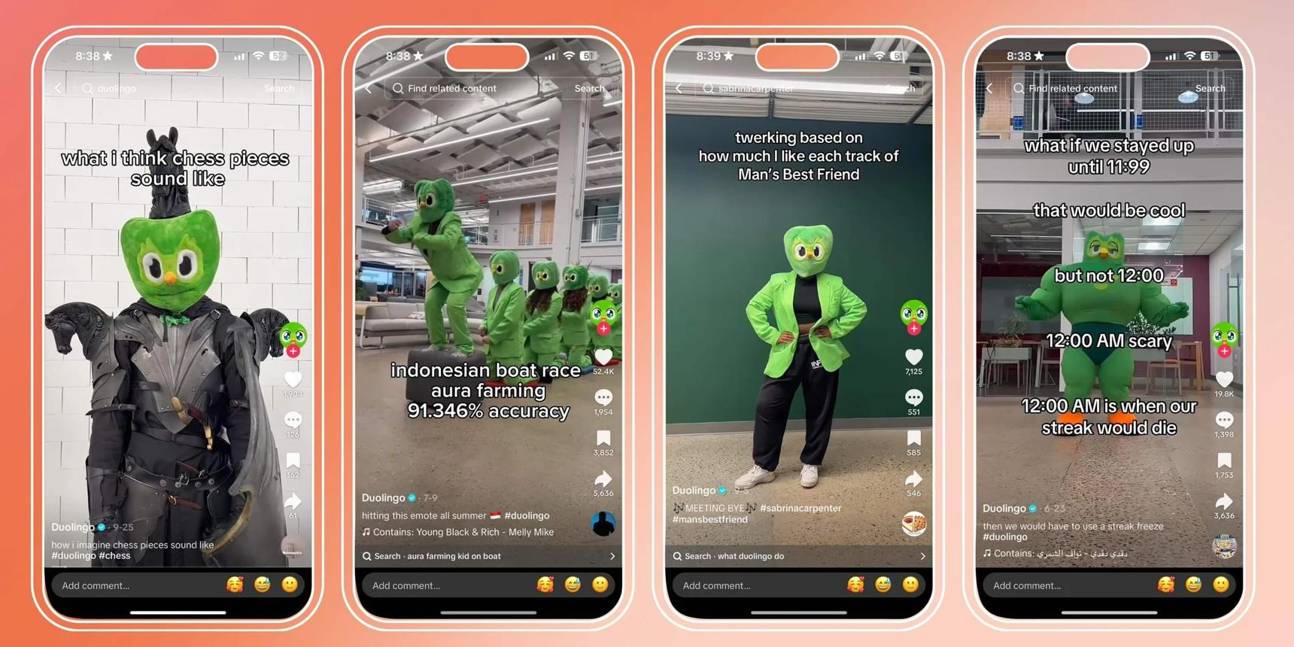
1. Turning a viral moment into a brand narrative
Duolingo capitalized on the viral announcement of Duo's death, then revived the mascot as a fictional cult leader. This extended an existing meme into a new story rather than creating an entirely unrelated campaign.
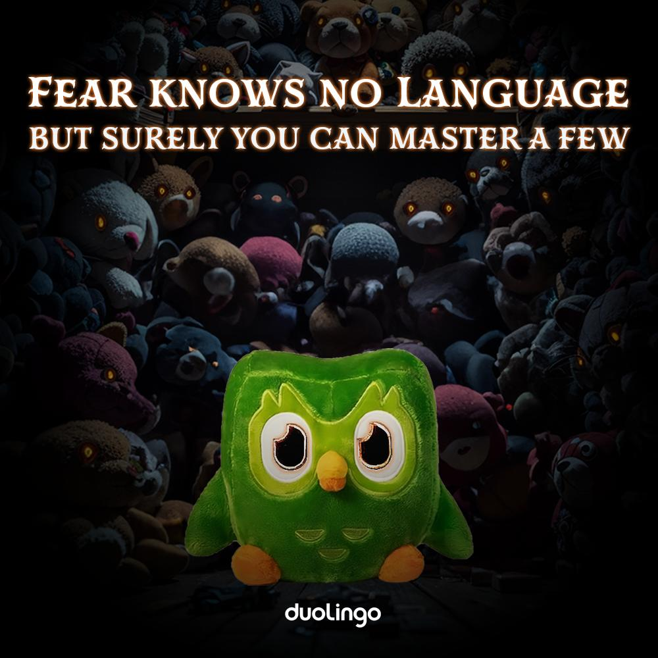
2. Developing a recognizable fictional universe
The campaign incorporated references to pop culture, including the film Eyes Wide Shut. Duolingo also incorporated its app mechanics into the story, turning learning streaks and reminders into humorous rituals.
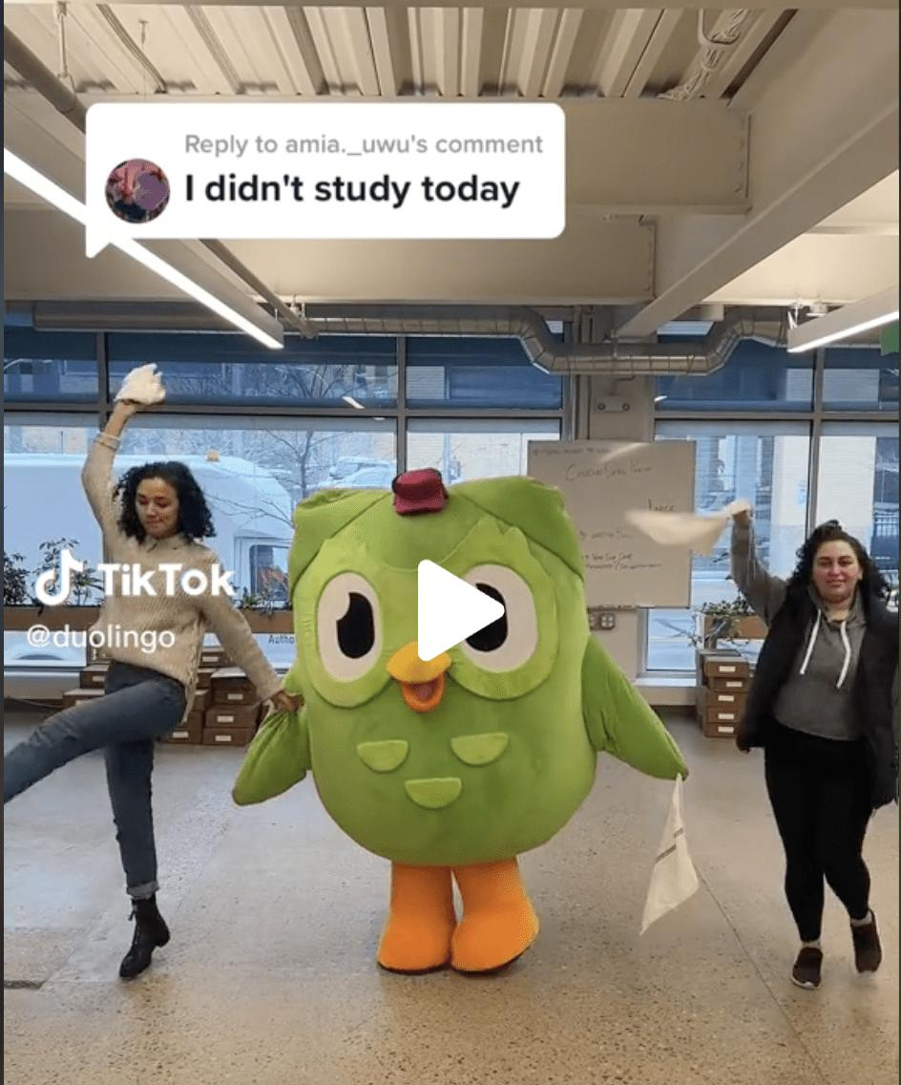
3. Creating TikTok-first content
The brand combined immersive point-of-view videos, cinematic scenes, and TikTok-native creative elements. Instead of simply repurposing conventional advertisements, it developed content suited to the platform's viewing habits.
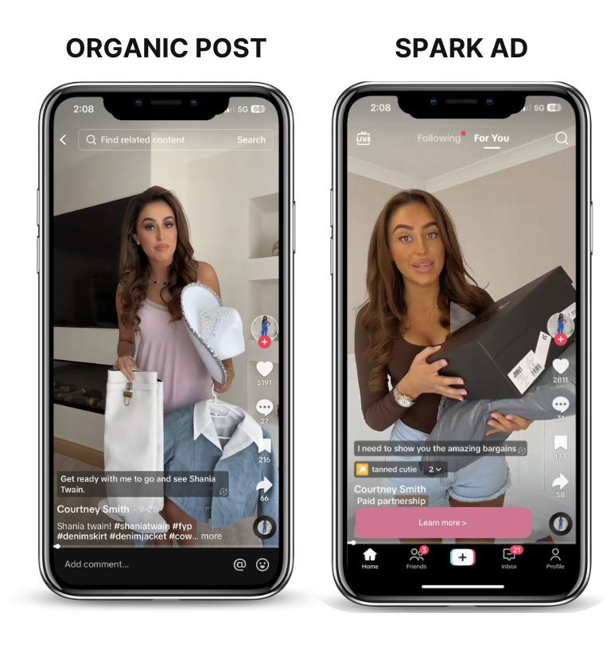
4. Amplifying successful content with Spark Ads
Duolingo used Spark Ads to expand the reach of content that had already resonated with its community. This combined organic engagement with paid distribution.
TikTok For Business

4. Campaign Results
DUOLINGO CAMPAIGN PERFORMANCE

34.83M
Impressions

26.89M
Reach

4.55M
Interactions

12.63%
Engagement rate
The campaign also generated 3.84 million reactions. These are figures reported by TikTok for the campaign in Germany.
TikTok For Business
The campaign's results illustrate how an entertaining narrative can generate substantial reach and active participation. The high number of reactions also suggests that audiences were responding to the story, rather than merely viewing the advertisements.
However, impressions and engagement are upper-funnel indicators. They do not, by themselves, demonstrate an increase in app downloads, revenue, or long-term customer loyalty.

5. Key Takeaways
|
Strategic element
|
Key takeaway
|
| --- | --- |
|
Meme marketing
|
A viral moment can become the foundation of a larger campaign.
|
|
Brand personality
|
A recognizable mascot can give a brand a consistent voice.
|
|
Storytelling
|
A continuing narrative can encourage audiences to follow multiple pieces of content.
|
|
Platform-native content
|
Content designed specifically for TikTok can feel more natural to its audience.
|
|
Paid amplification
|
Spark Ads can scale content that has already demonstrated audience appeal.
|
|
Community participation
|
Giving audiences a story to react to can generate conversations and interactions.
|
Central lesson: Duolingo did not simply use memes to attract attention. It transformed a meme into a recognizable brand story that audiences could follow, discuss, and share.
TikTok For Business

PART 2: Applying Duolingo's Meme Marketing Strategy to TRESemmé

Proposed Strategy: From Hair Memes to Hair Culture
Proposed business case solution
The objective for TRESemmé should be to adapt Duolingo's approach to the haircare industry, not simply copy its humor or mascot.
TRESemmé can use memes, relatable hair problems, and creator-led storytelling to make its products part of everyday online conversations. The campaign should connect entertainment with a clear product benefit, such as glossy hair, styling confidence, or salon-quality results.
This approach is particularly relevant because TRESemmé has already demonstrated the ability to execute TikTok campaigns using creators, branded effects, and paid amplification. Its Brazilian Lamellar Shine campaign, for example, used 35 creators over three months and generated 520 community-created videos.
TikTok for Business Case Study

1. How should the strategy be implemented?

Proposed campaign: The Glossy Hair Era
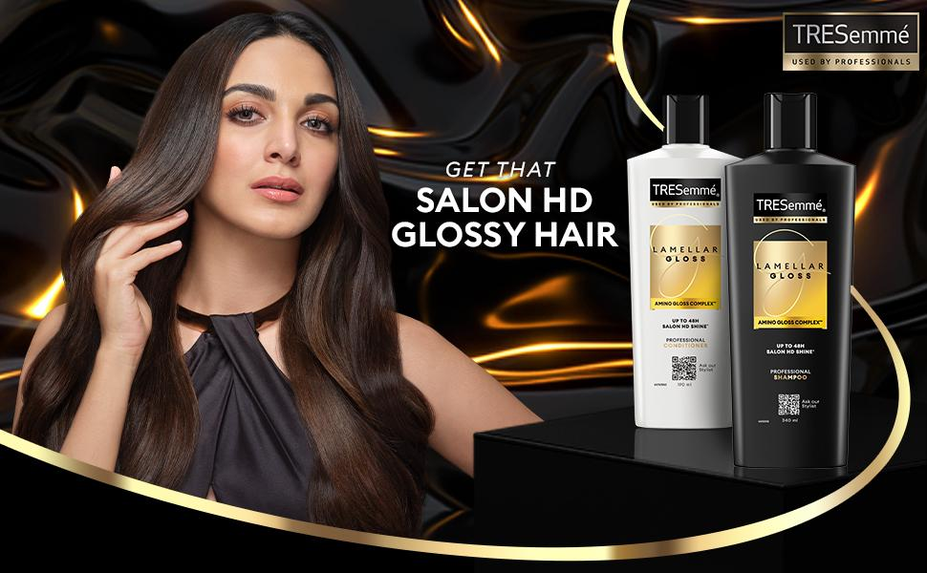
Illustrative creative direction, not an existing campaign.
Campaign concept: Turn common hair struggles and transformations into a series of humorous, relatable TikTok stories, with TRESemmé products integrated naturally into the content.
Core message: Every hair day has a story. TRESemmé helps you create your desired look.

A. Identify relevant internet trends and consumer insights
The first step is to identify the types of hair-related conversations that already exist among the target audience.
Potential themes include:
- Bad hair days and unexpected humidity.
- The difference between expectations and reality when styling hair.
- Preparing for an important event and wanting a particular hairstyle.
- Relatable situations involving frizz, dullness, or maintaining a hairstyle.
The marketing team should monitor TikTok trends, comments, hashtags, and creator content to identify recurring problems and popular formats.
Technical execution:
- Monitor TikTok's Creative Center and relevant social listening tools.
- Track trending audio, hair-related hashtags, and frequently discussed hair concerns.
- Categorize trends by relevance to TRESemmé's products and target audience.
- Prioritize trends that can naturally connect to a product benefit.
- Develop a content calendar that allows the team to respond while a trend is still relevant.
The key is to avoid joining every viral trend. TRESemmé should select trends that reinforce its identity as a haircare brand.

B. Develop a recurring meme-based storytelling format
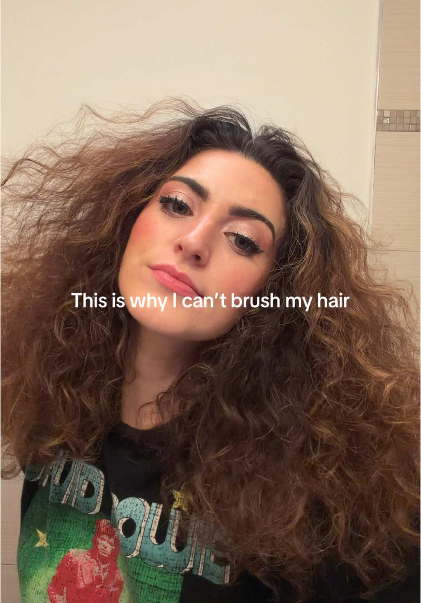
Rather than producing disconnected memes, TRESemmé could create a recurring series with a consistent format.
For example, a series called The Hair Emergency Files could feature creators encountering relatable hair problems before important occasions.
|
Episode
|
Storyline
|
Product integration
|
| --- | --- | --- |
|
1. The Humidity Incident
|
A creator's hairstyle changes unexpectedly before going out.
|
Introduce a relevant anti-frizz product, if supported by its claims.
|
|
2. The Last-Minute Invitation
|
A creator receives an unexpected invitation and has little time to style their hair.
|
Demonstrate a suitable styling routine.
|
|
3. The Glossy Hair Experiment
|
A creator tries to recreate a trending glossy hairstyle.
|
Show how a relevant TRESemmé product fits into the routine.
|
|
4. The Final Reveal
|
Creators share their finished hairstyles and their experiences.
|
Encourage authentic product reviews and user-generated content.
|
The episodes should have a consistent visual identity, recurring humor, and recognizable opening formats. Viewers should be able to understand the joke even if they have not seen previous episodes.

C. Collaborate with creators and encourage user-generated content
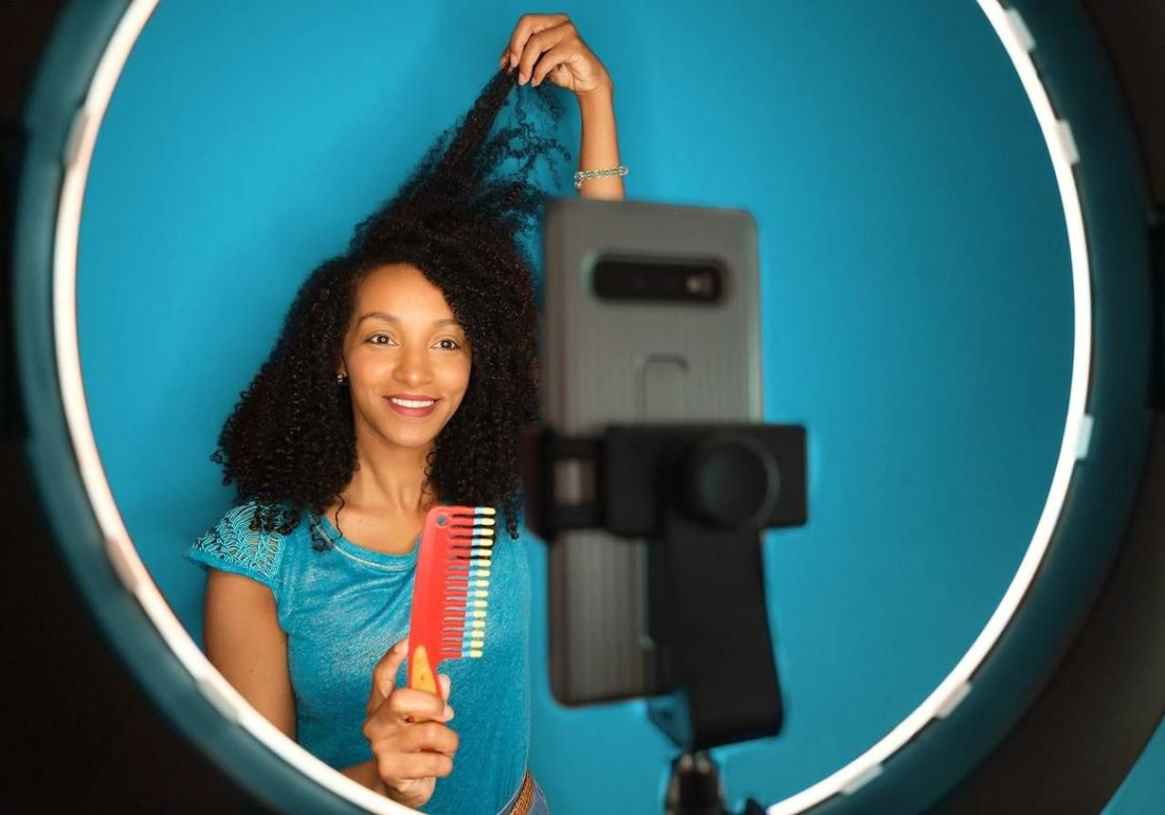
TRESemmé should collaborate with creators who already produce relatable haircare, beauty, lifestyle, and comedy content.
The campaign could use three creator groups:
- Micro-creators: Produce relatable hair memes and everyday styling content.
- Beauty creators: Demonstrate product usage and explain haircare routines.
- Larger creators: Introduce the campaign and generate broader awareness.
Creators could participate in a branded challenge, such as showing a relatable hair problem followed by their styling routine and final look.
Technical execution:
- Provide creators with a campaign brief containing the core message, product claims, and creative guidelines.
- Allow creators to adapt the concept to their own humor and audience.
- Introduce a branded hashtag and, where appropriate, a branded effect.
- Encourage audiences to recreate the format or share their own hair stories.
- Obtain permission to reuse suitable creator content in paid advertisements.
This combines Duolingo's community-centered approach with TRESemmé's existing experience in creator campaigns.

D. Amplify high-performing content using paid advertising
TRESemmé should not spend its entire advertising budget promoting every piece of content equally.
Instead, it could test several organic videos first, then use Spark Ads to amplify content that demonstrates strong audience response.
A proposed process:
- Publish several creative variations organically.
- Measure watch time, completion rate, shares, comments, and engagement.
- Identify videos that perform well relative to the campaign's other content.
- Use Spark Ads to expand the reach of selected videos.
- Retarget interested viewers with product demonstrations or shopping advertisements, subject to platform availability and applicable privacy rules.
The final stage should connect awareness to product discovery through relevant product pages or participating retailers.

E. Build a full-funnel campaign

Proposed campaign funnel

1. Awareness
Relatable memes and viral storytelling
Reach · Impressions · Views

2. Engagement
Creator challenges, comments, shares, and UGC
Engagement · Shares · UGC

3. Consideration
Product demonstrations, reviews, and routines
Product-page visits · CTR

4. Conversion
Shopping ads and retailer links
Conversion · Sales · ROAS
This approach ensures that meme marketing is not evaluated solely by views. It connects entertainment to product consideration and, eventually, measurable commercial outcomes.

2. Why could this strategy succeed?
There are five main reasons why this strategy could work for TRESemmé.
1. It makes the brand part of existing conversations.
Traditional advertisements interrupt entertainment, whereas memes can become entertainment themselves. By using familiar situations such as bad hair days, TRESemmé can participate in conversations that audiences already enjoy.
The Duolingo case demonstrates how a brand can extend an existing viral moment into a sustained narrative, generating 4.55 million interactions.
TikTok For Business
2. It makes product benefits easier to understand.
Haircare products can be difficult to differentiate through conventional advertisements. Relatable storytelling can demonstrate when and why someone might use a product.
For example, a humorous video about preparing for an important event can lead naturally into a hair styling routine. This makes the product relevant to the story rather than forcing an advertisement into it.
3. It encourages organic participation.
A simple, repeatable meme format allows creators and ordinary users to produce their own versions. This can expand the campaign beyond the brand's own social media accounts.
Duolingo's campaign illustrates the potential of building a community around recognizable characters and shared references.
TikTok For Business
4. It provides opportunities for efficient content testing.
TRESemmé can test different jokes, formats, creators, and product demonstrations before committing substantial advertising budgets.
By amplifying content that performs well organically, the brand can use audience responses to inform its paid media decisions. However, organic engagement does not guarantee that paid advertisements will produce the same results.
5. It builds on TRESemmé's existing capabilities.
This is not an entirely unfamiliar approach for the brand. Its Brazilian Lamellar Shine campaign already combined creator partnerships, TikTok-native content, branded effects, and paid distribution. The campaign achieved a 33% lower CPM than the beauty category average and a view-through rate 106% above the benchmark.
TikTok for Business Case Study
The proposed meme strategy would build on these existing capabilities while introducing more humor and recurring storytelling.

3. What could make the strategy fail, and how can TRESemmé mitigate the risks?

Risk assessment and mitigation
Potential risks and proposed solutions
Risk 1
The memes become popular, but the brand is forgotten.
A video might attract millions of views because it is funny, without audiences remembering that TRESemmé was involved.
Mitigation
Integrate recognizable brand elements, relevant product demonstrations, and consistent messaging into the content. Measure brand recall and product consideration in addition to engagement.
Risk 2
The brand appears inauthentic or tries too hard.
Audiences may reject memes that feel forced, outdated, or inconsistent with the creator's usual content.
Mitigation
Allow creators to adapt the campaign to their own voices. Monitor audience comments and avoid copying trends that do not fit the brand.
Risk 3
A trend becomes outdated before the campaign launches.
Meme formats can lose relevance quickly. A campaign that takes weeks to approve and produce may miss its opportunity.
Mitigation
Establish a rapid content approval process, prepare reusable creative templates, and maintain a flexible content calendar. Use longer-lasting haircare problems as the foundation instead of depending entirely on short-lived trends.
Risk 4
High engagement fails to translate into sales.
Users may enjoy the videos without having any intention of purchasing the products.
Mitigation
Include product demonstrations, creator reviews, clear product information, and links to participating retailers. Track click-through rates and sales separately from engagement.
Risk 5
Creators communicate inconsistent or misleading product claims.
A creator might exaggerate a product's benefits or make claims that are not supported by product evidence.
Mitigation
Provide clear claim guidelines, verify product statements before publication, and establish a content review process while preserving creative freedom.
Risk 6
The campaign becomes too dependent on one platform.
A campaign that relies entirely on TikTok may struggle to reach audiences who use other platforms.
Mitigation
Adapt successful content for Instagram Reels and YouTube Shorts. Use platform-specific editing and distribution rather than simply reposting identical videos everywhere.
The most important risk is the disconnect between entertainment and product value. TRESemmé needs to ensure that audiences remember not only the joke but also the product and the reason to consider it.

4. What would be the potential impact on TRESemmé if the strategy succeeds?
The expected impact can be divided into four areas. These are proposed outcomes, not guaranteed results.

1. Increased brand awareness
Meme-based content could expose TRESemmé to audiences who might not actively seek out haircare advertisements.
Potential KPIs: Reach, impressions, video views, brand recall, and branded search volume.

2. Stronger brand relevance and engagement
Consistent participation in relevant online conversations could help TRESemmé develop a more recognizable social media personality and build relationships with younger consumers.
Potential KPIs: Engagement rate, shares, comments, user-generated content, sentiment, and brand consideration.

3. Increased product consideration and sales opportunities
By connecting relatable hair problems with relevant product solutions, the campaign could encourage consumers to explore TRESemmé's product range.
Potential KPIs: Product-page visits, click-through rate, conversion rate, incremental sales, and return on ad spend.

4. Long-term brand equity
If the campaign consistently delivers relevant content and credible product experiences, it could strengthen TRESemmé's associations with modern hair trends, creativity, and accessible styling expertise.
Potential KPIs: Brand love, perceived relevance, trend association, repeat purchase, and customer retention.
TRESemmé's existing Brazilian campaign offers a useful example of the potential impact on brand equity. Its TikTok Brand Lift study reported a 27.3-point increase in Brand Love, a 19.5-point increase in Meets Needs, and a 19.2-point increase in Sets Trends. These were results from a particular campaign and audience, not forecasts for a new meme campaign.
TikTok for Business Case Study

PART 3: PPT-Ready Summary
For your competition presentation, the following structure condenses the analysis into four slides.
Slide 1

The Duolingo Model: Turning Memes into Brand Culture
Case study and evidence

34.83M
Impressions

12.63%
Engagement rate
Key strategy: Viral moment → recurring brand story → community participation → paid amplification.
Key insight: Memes can become more than isolated jokes when they are connected to a recognizable brand narrative.
Slide 2

TRESemmé's Proposed Strategy: The Glossy Hair Era
Technical execution
- Monitor trends and identify relevant haircare conversations.
- Create recurring, humorous hair-problem storytelling.
- Collaborate with micro-creators and beauty influencers.
- Encourage community participation through a branded challenge.
- Amplify successful videos using Spark Ads and connect them to shopping.
Key insight: Combine entertainment with credible product demonstrations to connect attention with product discovery.
Slide 3

Success Factors vs. Execution Risks

Success factors
- Cultural relevance
- Authentic creator voices
- Shareable storytelling
- Efficient creative testing

Execution risks
- Weak brand recall
- Forced humor
- Short-lived trends
- Low sales conversion
Mitigation: Combine rapid trend monitoring, creator flexibility, brand integration, and full-funnel measurement.
Slide 4

Expected Business Impact
- Awareness: Greater reach and brand recall.
- Engagement: More community participation and relevant conversations.
- Consideration: More interest in TRESemmé products and styling routines.
- Brand equity: Stronger associations with contemporary hair trends and styling expertise.
Success should be measured across the funnel, from awareness and engagement to product consideration and incremental sales.

Final strategic recommendation
The central opportunity for TRESemmé is to turn meme marketing into a repeatable content system rather than a one-time viral campaign. Duolingo demonstrates how a recognizable brand personality and continuing narrative can attract substantial attention. TRESemmé can adapt that principle through relatable haircare stories, creator-led content, and product demonstrations.
However, the campaign should be considered successful only if it achieves more than high engagement. The strongest evidence of business value would be a measurable improvement in brand consideration and incremental sales, alongside sustained audience engagement.
Suggested closing statement for your presentation:
"TRESemmé should not just follow internet trends. It should turn relatable hair moments into a recognizable brand culture, transforming online attention into meaningful consumer relationships and measurable business growth."
Sources
- TikTok for Business: Duolingo, TikTok Ad Awards 2025
- TikTok for Business: TRESemmé's 2024 hair trend campaign

